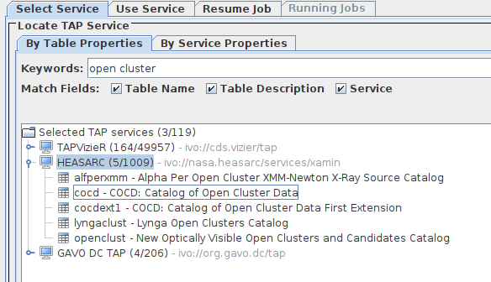
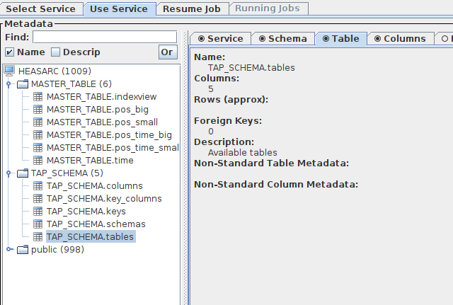

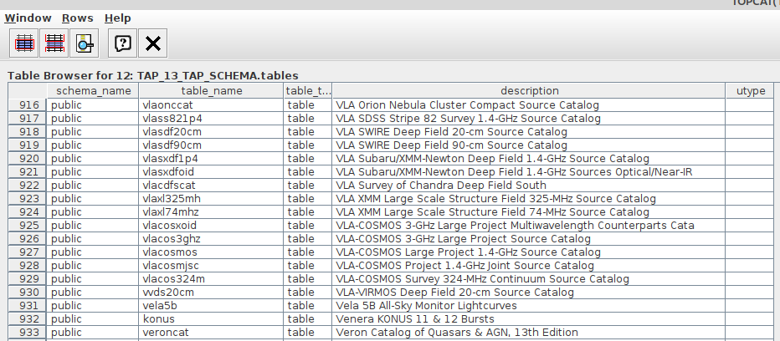
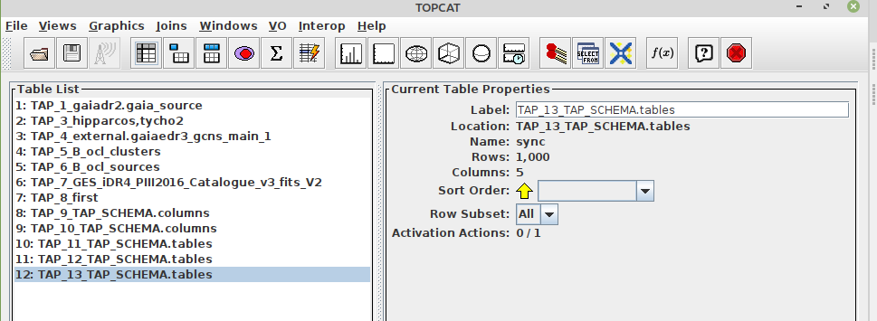

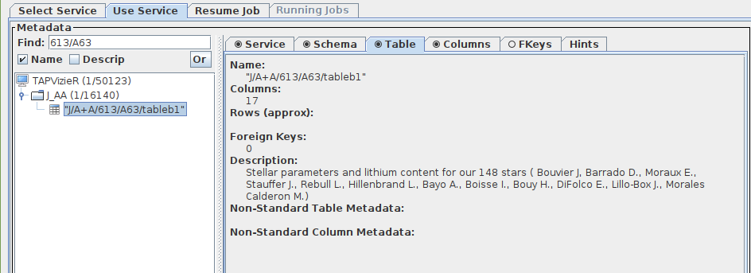

- SELECT recno, Teff, e_Teff, ALi, e_ALi, Age, e_Age FROM "J/A+A/653/A72/table1"
- SELECT recno, Teff, e_Teff, ALi, e_ALi, 19.0 as Age, 1.5 as pe_Age, -4.0 as ne_Age FROM "J/A+A/659/A85/tableb2" WHERE ALi IS NOT NULL
- SELECT recno, Teff, e_Teff, ALi, e_ALi, 21.0 as Age, 3.5 as pe_Age, -3.0 as ne_Age FROM "J/A+A/659/A85/tableb3" WHERE ALi IS NOT NULL
- SELECT recno, Teff, e_Teff, ALi, e_ALi, 19.0 as Age, 1.5 as pe_Age, -7.0 as ne_Age FROM "J/A+A/659/A85/tableb1" WHERE ALi IS NOT NULL
- SELECT recno, Teff, e_Teff, ALi, e_ALi, 30.0 as Age, 3.0 as pe_Age, -5.0 as ne_Age FROM "J/A+A/659/A85/tableb4" WHERE ALi IS NOT NULL
- SELECT recno, Teff, e_Teff, ALi, e_ALi, 35.0 as Age, 4.0 as pe_Age, -4.0 as ne_Age FROM "J/A+A/659/A85/tableb5" WHERE ALi IS NOT NULL
- SELECT recno, Teff, e_Teff, ALi, e_ALi, 138.0 as Age, 48.0 as pe_Age, -42.0 as ne_Age FROM "J/A+A/659/A85/tableb6" WHERE ALi IS NOT NULL
- SELECT TOP 1000 * FROM gaiaedr3
- SELECT a.Cname, a.Teff, a.GaiaEDR3, b.ra, b.dec FROM "J/A+A/659/A85/tableb1" a JOIN gaiaedr3 b ON a.GaiaEDR3 = b.source_id
- SELECT TOP 1000 * FROM GES_DR5
- SELECT TOP 1000 * FROM GES_DR5 where ges_fld = 'NGC2547'
- SELECT TOP 1000 * FROM GES_DR5 where ges_fld = 'NGC2451'
- SELECT TOP 1000 * FROM GES_DR5 where ges_fld = 'NGC2516'
- SELECT object, ra, declination, teff, e_teff, logg, e_logg, Li1, E_Li1, MEM3D FROM GES_DR5 where ges_fld = 'NGC2516'
- select distinct ges_fld from ges_dr5
- select distinct ges_type from ges_dr5
- select distinct ges_fld from ges_idr4_piii2016_Catalogue_v3_fits_v2
- SELECT object, ra, declination, teff, e_teff, logg, e_logg, FEH, E_FEH, Li1, E_Li1, ges_fld, MEM3D FROM GES_DR5
- SELECT * FROM EDR3.GAIA_SOURCE WHERE SOURCE_ID = '3234193283936882432'
- SELECT object, ra, declination, teff, e_teff, logg, e_logg, FEH, E_FEH, Li1, E_Li1, ges_fld FROM GES_DR5 where logg <= 4.5 and ges_fld is not null and Li1 is not null and ges_fld like '25%' and teff >= 4250 and teff <= 4450
- SELECT distinct ges_fld FROM GES_DR5 where ges_type like 'GE_CL%' or ges_type like 'GE_SD_OC%

https://gaia.obspm.fr:443/tap-server/tap/async/1657449411968

SELECT object, teff, e_teff, logg, e_logg, FEH, E_FEH, Li1, E_Li1, ges_fld
FROM GES_DR5
where logg <= 4.5
and Li1 is not null
and ges_fld like '25%'
and teff >= 4250 and teff <= 4450

* List Open Cluster and number of member
SELECT distinct ges_fld, count(*) members
FROM GES_DR5
where ges_type
like 'GE_CL%' or ges_type like 'GE_SD_OC%' or ges_type like 'AR_CL%' or ges_type like 'AR_SD_OC'
group by ges_fld
order by ges_fld

SELECT object, teff, e_teff, logg, e_logg, FEH, E_FEH, Li1, E_Li1, ges_fld
FROM GES_DR5
where (ges_type like 'GE_CL%' or ges_type like 'GE_SD_OC%' or ges_type like 'AR_CL%' or ges_type like 'AR_SD_OC')
AND LI1 IS NOT NULL
AND FEH is not null
AND GES_FLD IS NOT NULL
AND TEFF IS NOT NULL
AND LOGG IS NOT NULL
AND NN_TEFF IS NOT NULL
AND NN_LOGG IS NOT NULL
AND NN_FEH IS NOT NULL
order by ges_fld

SELECT object, teff, e_teff, logg, e_logg, FEH, E_FEH, Li1, E_Li1, ges_fld
FROM GES_DR5
where ges_fld in (
SELECT distinct ges_fld
FROM GES_DR5
where ges_type
like 'GE_CL%' or ges_type like 'GE_SD_OC%' or ges_type like 'AR_CL%' or ges_type like 'AR_SD_OC' )
AND LI1 IS NOT NULL
AND FEH is not null
AND GES_FLD IS NOT NULL
AND TEFF IS NOT NULL
AND LOGG IS NOT NULL
AND NN_TEFF IS NOT NULL
AND NN_LOGG IS NOT NULL
AND NN_FEH IS NOT NULL
order by ges_fld

